**Task**: create a SP (stored procedure) with the input parameters listed in **Table 1**.

Table 1 – required input parameters for the stored procedure

|  |  |  |  |
| --- | --- | --- | --- |
| **Parameter name** | **Data type** | **Description** | **Input values description** |
| @p_DatabaseName | NVARCHAR(MAX) | Needed for selection of a database for the further statistics gathering. | Any string value |
| @p_SchemaName | NVARCHAR(MAX) | Needed for selection of a database schema within the selected database for the further statistics gathering. | Any string value |
| @p_TableName | NVARCHAR(MAX) | Needed for selection of particular table or set of tables for the further statistics gathering. | Any string value for analysis of one particular table.  If user wants to analyze all existing tables within the selected schema – he should be able to pass only “%” symbol. |

Stored procedure should analyze all the objects passed to it and provide a detailed statistic about the DB tables to the user. Any T-SQL statements can be used in the task solution. Detailed output list is described in the end of the document. Example of the procedure output is shown on the below picture:

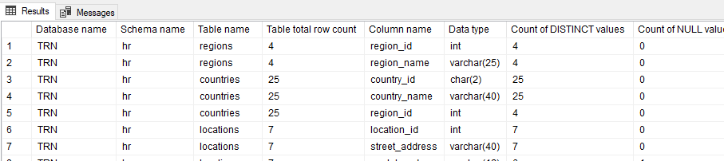

General requirements to the solution:

1. User should input the above parameters into the SP and get all the output list. No additional actions should be done from the user’s side.
2. **TRN** database can be used as a representation of working result but user must be able to launch the current script on any SQL Server database he wants.
3. No additional commands should be done for giving the permissions to the user that will execute the SP. Assume that target user has sysadmin permissions.
4. No physical tables should be used for the temporary data storage purpose within the current SP. Temporary tables and table variables are allowed.

## Output list description

Using the described input parameters, the stored procedure should provide the following output to the user:

|  |  |
| --- | --- |
| **Column name** | **Description** |
| Database name | Name of a database selected by user through input parameter. |
| Schema name | Name of a database schema selected by user through input parameter. |
| Table name | Name of a table selected by user through input parameter. If user selected % - all the tables within the current schema should be listed. |
| Total row count | Count of rows in the current table. |
| Column name | Name of a column of a current table. |
| Data type | Data type of a current column of a current table. |
| Count of DISTINCT values | Count of DISTINCT values in the current column. |
| Count of NULL values | Count of NULL values in the current column. |
| Count of empty/zero values | Count of zero values (in case of numeric column) or empty values (in case of string column) in the current column. |
| Only UPPERCASE strings | In case of string column – count of values that contain only uppercase letters. In case of uppercase letters + special symbols or numbers – count such rows also. |
| Only LOWERCASE strings | In case of string column – count of values that contain only lowercase letters. In case of lowercase letters + special symbols or numbers – count such rows also. |
| Rows with non-printable characters at the beginning/end | In case of string column – count of rows with non-printable symbols in the beginning or in the end of the string (spaces, tab values, line breaks, etc.). |
| Most used value | Most popular value for the current column. |
| % rows with most used value | Percentage, how much rows in the current column contain the most popular value.  For **example**: most used value for **[Employees]** table – **job_id** column = **6;**  % rows with most used value = **12.5%**. It means that **12.5%** of rows in **[Employees]** table contain **job_id** = **6**. |
| MIN value | Minimum value in the current column. |
| MAX value | Maximum value in the current column. |